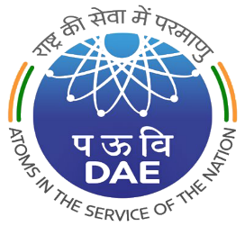 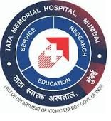

**TATA MEMORIAL CENTRE**

**TATA MEMORIAL HOSPITAL**

**PAREL, MUMBAI – 400 012**

***(A GRANT-IN-AID INSTITUTE UNDER DEPARTMENT OF ATOMIC ENERGY, GOVT. OF INDIA)***

TMC/ACAD/87/2025 02.07.2025

**WALK-IN-INTERVIEW on 21.07.2025** for **01 YEAR TMC FELLOWSHIP & SENIOR RESIDENT (PROTON THERAPY) IN THE DEPARTMENT OF RADIATION ONCOLOGY**

**Reporting Time & Venue: 09:00 A.M. to 09:30 A.M. at Homi Bhabha Block, 13th Floor, Training Cell, Tata Memorial Hospital, Parel, Mumbai**

|  |  |  |
| --- | --- | --- |
| **Sr.**  **No.** | **DESCRIPTION** | **ESSENTIAL QUALIFICATIONS** |
| 1 | SENIOR RESIDENT  (PROTON THERAPY) | MD / DNB in Radiation Oncology OR equivalent PG degree with 01 year of experience. |
| 2 | NEURO RADIATION ONCOLOGY FELLOWSHIP |
| 3 | THORACIC RADIATION ONCOLOGY FELLOWSHIP |

**CONSOLIDATED REMUNERATION :** Rs. 1,27,260/- p.m. (Gross Pay)

**AGE LIMIT**: 40 YEARS. (Relaxable by 5 years for SC/ST, 3 years for OBC & 10 years for Physically Handicapped).

Eligible and Interested candidates may attend walk-in-interview. Please bring Resume, recent passport size photograph with attested copies of all qualification & experience certificates. **[Any doubts regarding the post may be clarified by emailing to: tmhresident@tmc.gov.in.]**

**( S.D. BANAVALI)**

**DIRECTOR (ACADEMICS), TMC**