  

**MAHAMANA PANDIT MADAN MOHAN MALAVIYA CANCER CENTRE**

**&**

**HOMI BHABHA CANCER HOSPITAL,**

**VARANASI**

**Units of**

**(TATA MEMORIAL CENTRE)**

**Notice Inviting Tender**

**Tenders invited for Immunoassay Analyser Automated on Regent Rental 02 Years plus Extendable for 01 Years subject to satisfactory performance and requirement for Biochemistry Department at HBCH & RC, Muzaffarpur**

Tender No. : HBCH/MPMMCC-MZP/OT/02/KE

Date of Publication : 01/06/2022

Last Date of Submission : 21/06/2022 up to 13:00 Hrs.

Opening of Technical Bid : 21/06/2022 from 14:30 Hrs.

**Tender notice for supply of Immunoassay Analyser Automated on Reagent Rental Contract for Biochemistry Department at HBCH & RC, Muzaffarpur**

# Last date of Submission: 21.06.2022 up to 13:00 hrs.

# Tender Opening date: 21.06.2022 from 14:30 hrs.

# TENDER No. HBCH/MPMMCC-MZP/OT/02/KE Date: 01.06.2022

1. Sealed tender invited by **MPMMCC & HBCH** in two bid systems i.e. Part-I (Technical Bid) & Part –II (Financial Bid) for the supply of Auto Analyzer on Reagent Rental Contract for Biochemistry Department at HBCH & RC, Muzaffarpur.
2. The said tender should be submitted **along with supporting documents (as required per the formats attaches as ‘Annexure -I’, ‘Annexure- B, C, D, E, F, G & H) along with supporting documents) and ‘Part II- Financial Bid’ (as per format ‘Annexure -II’) respectively and each to be submitted in separate envelopes.**

Sealed Envelopes of Both Part – I and Part – II tenders are to be sealed in separate envelope of suitable size & super-scribed ‘**Ref. No. HBCH/MPMMCC-MZP/OT/02/KE** addressed to the **“Director (MPMMCC/HBCH), Mahamana Pandit Madan Mohan Malaviya Cancer Centre, Sundar Bagiya, Near Nariya Gate, Varanasi (U.P.) – 221005 Ph. 0542 2575035, 2575032; Ext. No. 1132”** should reach Purchase Department on or before **21.06.2022 up to 13:00 Hrs.**

**The Part I- Technical Bid shall be opened at 14:30 hrs. on the same day i.e. on 21.06.2022.**

1. After opening the technical bid, the **Documents** submitted by the respective tenderers will be evaluated and **financial bid** will be opened only of techno-commercially qualified tenderers. The time and date will be intimated to such tenderers.
2. Time and date of opening of **Part II- Financial Bid** will be intimated only to the tenderers who will be qualified after evaluation Part I- (Technical Bid) i.e. Part II of the tenders will be opened on a date to be intimated later, only if respective sample/s & Part I of the bid is technically accepted.

**Only technically qualified and commercially lowest offers will be considered for further process.**

1. **Bid Security Declaration:** The tenderer has to submit the “Bid Security Declaration” as per ANNEXURE ‘B’ attached in the tender document.
2. No tender will be accepted unless the Bid Security Declaration is enclosed along with **Part I- Technical Bid** of tender document.
3. **Pre-Qualification Criteria:**
4. Bidder should be the manufacturer/authorized dealer/Distributor/Trader/Supplier. Supporting documents for the applicable category required to be submitted and Letter of authorization from manufacturer for the same & specific to the tender should be submitted.
5. Tenderer must provide evidence of having supplied government hospital / reputed private hospital/reputed organizations in India similar nature of items in the last two years and the copy of the same should be submitted.
6. The tender document must be accompanied by copy of PAN, Certificate of registration of firm/ company registration, GST registration Certificate.
7. Latest Government of India guidelines on “Purchase Preference to Make in India” vide Order No. P-45021/2/2017-PP (BE-II) dated 04.06.2020 & 16.09.2020: - The quoted products must have at least 50% of local content in terms of quoted value for the quoted item/items.
8. Latest Government of India guidelines on “Public Procurement Policy for Micro and Small Enterprises (MSEs) Order, 2012” & Subsequent amendments from time to time will be applicable. The copy of valid UAM/URC must be submitted if available.
9. Latest Government of India guidelines “Mandatory Conditions to be satisfied by any bidder from a Country which shares a land border with India” placed at **Annexure E.**
   * + 1. Self-attested copy of **Annexure E** Mandatory conditions to be satisfied by any bidder from a country which shares a land border with India. – Bidder to confirm
       2. Certificate of compliance of clauses of **Annexure E**, clause A VII. – Bidder to confirm
       3. Certification as per last paragraph of **Annexure E** Mandatory conditions to be satisfied by any bidder
10. **Performance Security:** The successful tenderer will have to enter into a contract for supply of **Immunoassay Analyser for Biochemistry on Reagent Rental Contract basis for two years,** A Performance Security deposit of 3% of Contract Value (including GST) to be paid either through DD or in the form of Bank Guarantee to be given for satisfactory performance for the period of Guarantee/ warranty + 03 months.

Performance guarantee should remain valid for a period of Ninety days beyond the date of completion of all contractual obligations of the vendor.

Those vendors who have paid Security deposit/Performance bank guarantee must be taken back by the vendor within 3 months of expiry period. If not collected within 3 months the expired Bank Guarantee shall be destroyed.

1. Scope of work:

Scope of supply should include supply of Immunoassay Analyser FOR BIOCHEMISTRY ON REAGENT RENTAL CONTRACT BASIS FOR TWO YEARS against purchase order/s as per technical specifications, quantity, delivery place (FOR: Destination i.e. HBCH& RC, Muzaffarpur) & delivery schedule indicated in the respective purchase order & provide GUARANTEE/ WARRANTY /CAMC/technical support for throughout contract period.

Further the for required reagents RATE CONTRACT on the approved rates will be issued for period of two years & supplies of reagents should be made against the respective Purchase Orders.

1. The damages if occurred to the items/equipment’s during transit up to its supply shall be taken care by the supplier/agent either by himself or through second party obligation by way of goods insurance to be arranged with a reputed goods insurance company and no obligation will be there on the part of the purchaser and every step whatever is required to be taken shall be initiated and taken by the agent.
2. The quantity shown against each item/s is approximate and may vary as per demand of the Institute at the time of placement of order.
3. **GUARANTEE/ WARRANTY:** The materials offered shall be guaranteed / warranted for satisfactory performance for a period of 24 months OR up-to the contract period from the date of supply & acceptance OR installation (if applicable) whichever is later, against manufacturing defects, bad workmanship, faulty materials, etc.

* **Guarantee/Warranty period and terms of guarantee/warranty including accessories, details of preventive / periodic maintenance, frequency and task description must be specified.** Vendors are required to provide warranty/CMC for the contract period from the date of supply & acceptance OR installation & commissioning (if applicable) whichever is later of item/product/equipment, tenders not confirming to this clause are liable to be rejected.
* Spares: If required for any of the item, essential spares are likely to be required during the period of warranty/CMC must be supplied with the equipment.
* Consumables: Consumables required during installation, startup, commissioning and trial runs are to be supplied by the supplier of the equipment. All consumables required for the working of the equipment should be quoted for in the commercial bid.

1. **Supply & Declaration:**

Suppliers must be written declaration for their respective supplies that “everything to be supplied by us hereunder shall be free from all defects and faults in material, workmanship and shall be of the highest quality and material of the type ordered, shall be in full conformity with the specification and shall be completed enough to carry out the experiments, as specified in the tender document.” If item fails, the same shall be replaced free of cost including all the applicable charges (shipping cost both ways).

**Supply must be done within stipulated time period from the date of delivery of the item/ equipment as specified in the purchase order.**

##### **Award of Contract/Purchase Order**

The Purchaser will award the contract/purchase order to the bidder whose quotation has been determined to be substantially responsive and who has bided the lowest evaluated quotation price & **L1 Grading will be done based consolidated basis on the cost per test CPRT**.

* 1. Notwithstanding the above, the Purchaser reserves the right to accept or reject any quotations and to cancel the bidding process and reject all quotations at any time prior to the award of contract.
  2. The bidder whose bid is accepted will be notified of the award of contract by the Purchaser prior to expiration of the bid validity period. The terms of the accepted bid shall be incorporated in the purchase order.

1. Normal comprehensive warranty/guarantee and CMC (if applicable) shall be applicable to the supplied goods as per Annexure-I (if mentioned).
2. Rates should be quoted inclusive of packing, forwarding, postage and transportation charges etc.
3. The competent authority reserves all rights to reject the goods if the same are not found in accordance with the required description / specifications/quality.
4. If the Vendor Capability Proforma provided and the documents required as mentioned are not submitted, MPMMCC/HBCH reserves the right not to accept the offer.
5. The Director, MPMMCC/HBCH reserves the right of cancellation, adding, reducing or deferring the purchase without assigning any reason thereof and claim in this behalf in any way shall not be tenable for compensation in one way or the other.  In such case the bidder will be refunded with the earnest money deposit without any payment of interest. The Director, MPMMCC/HBCH on enquiry will disclose the reasons for rejecting a tender or non-issuing a tender document.
6. If a firm quotes “NIL” charges/consideration, the bid shall be treated as unresponsive and will not be considered.

**Other Terms & Conditions:**

1. **Delivery & Installation:** The successful bidder should strictly adhere to the following delivery schedule supply, installation & commissioning (if/as applicable) should be effective within **Two Week** from the date of purchase order and this clause should be strictly adhere to failing which administrative action as deemed fit under rules will be taken against the defaulter. Otherwise Liquidation Damages will be imposed as per clause no. 2. Purchase order will be placed as required by consignee
2. **Penalty:** If the suppliers fails to deliver and place any or all the Equipment or perform the service by the specified date as mention in purchase order, penalty at the rate of 0.5% per week of delayed value of goods subject to the maximum of 10% of delayed goods value will be deducted, afterwards another penalty may be imposed.

The supplier will be required to give the guarantee towards the performance of the equipment during the warranty period and in case of Comprehensive maintenance contract period for maintaining the equipment in good working condition for a period of at least 300 days out of a period of 365 days a year (i.e. 95% uptime) 24X7. The ten hours non-functioning of the equipment or any part thereof will be considered as one day down time. Total 3000 hours in a year will be considered as Uptime guarantee. Working time is 8.00 a.m. to 6.00 p.m. on week days and 8.00 a.m. to 4.00 p.m. for Saturdays. The equipment shall be fully functional as part of the uptime and if it is partly functional it shall be considered as downtime and deduction shall be made on Pro-rata basis i.e. if the equipment is 70% functional 30% downtime shall be applicable. The decision of the MPMMCC/HBCH management or its representative in determining the % of the downtime shall be final and binding. Essential period to shut down the installation entirely or partially shall also be included in the down time while calculating the 95% guaranteed uptime i.e. all features as per specifications in purchase order should be functional for uptime. The supplier / agent shall be required to pay a penalty for every day 0.1% of the total cost of equipment per day per machine excluding 150 hours permissible downtime. This rate shall increase commensurate with the rate increase of CMC. If the number of days downtime in each period of 365 days is more than the downtime permissible (which is to be calculated as defined above), the delay for not bringing the equipment in functioning order in any way, directly or even partially will be attributable to the firm. The bidder should provide the details of preventive maintenance to be undertaken through the year. Preventive maintenance to be done on holidays only. Preventive maintenance and breakdown will not be clubbed. The quarterly CMC bills should be raised at the end and to be supported by preventive maintenance report / breakdown reports, downtime if any and duly signed by Head, user department and will be paid at the end of every quarter only.

1. **Right of Acceptance:** HBCH/MPMMCC reserves the right to accept or reject any or all tenders/quotations without assigning any reason there of and also does not bind itself to accept the lowest quotation or any tender. HBCH/MPMMCC also reserves the rights to accept all the items/equipment/instruments in the given tender or only part of it in any given schedule without assigning any reason.
2. **Validity of the bids:** The bids shall be valid for a period of **two years** from the date of opening of the tender. This has to be so specified by the tenderer in the commercial bid which may be extended, if required.
3. **Risk Purchase & Recovery of sums due:**

* Failure or delay in supply of any or all items as per Requisition / Purchase Order, Specification or Brand prescribed in the tender, shall be treated as 'non-compliance' or 'breach of contract' and the order in part of full be arranged from alternative source(s) at the discretion of the hospital authority and the difference in price has to be recovered from the tenderer as mentioned elsewhere.
* The amount will be recovered from any of his subsequent / pending bills or security Deposit.
* In case the sum of the above is insufficient to cover the full amount recoverable, the contractor shall pay to the purchaser, on demand the remaining balance due.

1. **Communication of Acceptance:**

HBCH / MPMMCC, Varanasi reserves all right to reject any tender including of those tenderers who fails to comply with the instructions without assigning any reason whatsoever and does not bind itself to accept the lowest or any specific tender. The decision of this Institute in this regard will be final and binding.

#### Insolvency etc.:

In the event of the firm being adjudged insolvent or having a receiver appointed for it by a court or any other under the Insolvency Act made against them or in the case of a company the passing any resolution or making of any order for winding up, whether voluntary or otherwise, or in the event of the firm failing to comply with any of the conditions herein specified, HBCH / MPMMCC, Varanasi shall have the power to terminate the contract without any prior notice.

1. **Force Majeure:**

If, at any time during the subsistence of this contract, the performance in whole or in part by either party of any obligation under this contract is prevented or delayed by reasons of any war or hostility, act of public enemy, civil commotion, sabotage, fire, floods, exception, epidemics, quarantine restriction, strikers lockout or act of God (hereinafter referred to as events) provided notice of happening of any such eventuality is given by party to other within 21 days from the date of occurrence thereof, neither party hall by reason of such event be entitled to terminate this contract nor shall either party have any claim for damages against other in respect of such non-performance or delay in performance and deliveries have been so resumed or not shall be final and conclusive.

Further, that if the performance in whole or in part of any obligation under this contract is prevented or delayed by reason of any such event for a period exceeding 60 days, HBCH / MPMMCC, Varanasi party may, at least option to terminate the contract.

1. **Breach of Terms and Conditions:**

In case of breach of any terms and conditions as mentioned above, the Competent Authority, will have the right to cancel the contract without assigning any reasons thereof and nothing will be payable by HBCH / MPMMCC, Varanasi. In that event the security deposit shall also stand forfeited.

1. **Subletting of contract**:

The firm shall not assign or sublet the contract or any part of it to any other person or party without having first obtained permission in writing of HBCH/MPMMCC, Varanasi, which will be at liberty to refuse if thinks fit. The tender is not transferable.

1. **REPEAT ORDER:**

The Hospital has right to place Order with mutual acceptance of contractor/supplier for an additional quantity equal to 100% of the original Order with the successful bidders at same rates, terms & conditions within a period of 01 Year from the date of Order or during the currency of the Order.

#### Right to call upon information regarding status of contract:

The HBCH / MPMMCC, Varanasi will have the right to call upon information regarding status of contract at any point of time.

1. **L1 will be decided items rate FOR HBCH/MPMMCC, Varanasi.**

(Rate wise comparison of the quotes will be made and **L1 Grading will be done based consolidated on the cost per test CPRT** accordingly. In this context, final decision of the committee will be binding to all and no claim in this regard can be entertained. The quantity indicated is tentative and may vary, and any decision in this regard by Director HBCH / MPMMCC, Varanasi shall be final.)

1. **Terms of payment:**

100% payment within 30 Days will be released after the successful supply & acceptance by consignee and submission of PBG @3% of Purchase Order Value in form of DD/Bank Guarantee for 27 months.

OR

80% payment against delivery at site & preliminary inspection and balance 20% after installation & commissioning and final acceptance and submission of PBG @3% of Purchase Order Value in form of DD/Bank Guarantee for 27 months.

No payment shall be made for rejected Stores. Rejected items must be removed by the supplier within two weeks of the date of rejection at their own cost & replace immediately. In case these are not removed these will be auctioned at the risk and responsibility of the suppliers without notice.

**For payment supplier should submit following documents.**

1. Three copies of Invoice.
2. Packing list/delivery challan.
3. Any other documents, if required.
4. **GSTs (Goods & Service Tax): -**

* GST rates applicable on your quoted item may please be informed.
* In the event of increase/decrease in GST, detailed justification and supporting evidence may be submitted for our consideration.
* HSN Code for relevant item should be clearly mentioned.

1. **Fall Clause:**
2. Prices charged for supplies under Rate Contract by the supplier should in no event exceed the lowest prices at which he bids to sell or sells the stores of identical description to any other State Government/DGS&D/Public Undertaking during the period of the contract.
3. If at any time during the period of contract, the prices of tendered items are reduced or brought down by any law or Act of the Central of State government, the supplier shall be bound to inform Purchasing Authority immediately about such reduction in the contracted prices, in case the supplier fails to notify or fails to agree for such reduction of rates, the Purchasing authority will revise the rates on lower side. If there is a price increase for any product after quoting the rates, the bidder will have to supply the item as per quoted rates. This office will not accept any higher rates after wards.
4. If at any time during the period of contract, the supplier quotes the sale price of such goods to any other State Govt. /DGS&D and Pubic Undertakings at a price lower than the price chargeable under the rate contract he shall forthwith notify such reduction to Purchasing Authority and the prices payable under the rate contract for the equipment’s supplied from the date of coming into force of such price stands correspondingly reduced as per above stipulation.

Any deviation in the material and the specifications from the accepted terms may liable to be rejected and the suppliers need to supply all the goods in the specified form to the satisfaction/ specifications specified in the Purchase order and demonstrate at their own cost.

1. **Offers with conditions/ambiguity/incomplete shall be liable to be rejected.**
2. Rules and regulations of the tender will be the part of contract.
3. **DEVIATIONS:** No deviation in make offered is permitted. However, for exceptional techno commercial reasons if any deviation is felt necessary by the firm, it must be clearly indicated along with reasons.
4. Non-compliance of any of these conditions or any of the conditions mentioned in the documents renders the purchaser to blacklist the supplier along with appropriate legal action.
5. **Arbitration:**

If any difference arises concerning this agreement, its interpretation on payment to the made there under, the same shall be settled out by mutual consultation and negotiation. If attempts for conciliation do not yield any result within a period of 30 days, either of the parties may make a request to the Director, HBCH/MPMMCC, Varanasi to settle the dispute by Sole Arbitrator. Sole arbitrator will be appointed by the Director, HBCH/MPMMCC, Varanasi. In case of such arbitrator refusing, unwilling or becoming incapable to act or his mandate having been terminated under law, another arbitrator shall be appointed in the same manner from among the panel of three persons to be submitted by the claimant. The provision of Arbitration and Conciliation Act, 1996 and the rule framed there under and in force shall be applicable to such proceedings.

1. **Legal Jurisdiction:**

The agreement shall be deemed to have been concluded in Varanasi, Uttar Pradesh and all obligations hereunder shall be deemed to be located at Varanasi, Uttar Pradesh and Court within Varanasi, Uttar Pradesh will have Jurisdiction to the exclusion of other courts.

**PURCHASE OFFICER**

**Annexure – A**

**Schedule of Quantity**

**TENDER No. HBCH/MPMMCC-MZP/OT/02/KE**

|  |  |  |  |  |
| --- | --- | --- | --- | --- |
| **Sl. No.** | **Item Code** | **Items Description** | **Total tentative requirement** | **Technical Specifications** |
| **1** | **AIMAN001** | **Immunoassay Analyser Automated on Reagent Rental Contract**  **As per technical specifications** | **01 No.** | **Annexure A1** |
| **1.1** |  | **Reagents for Immunoassay Analyser Automated** | **For 2 Years** |

**Note:**

1. **The above-mentioned quantities are tentative only; the supply orders of respective items will be given as per actual requirement of respective hospital/s (HBCH & RC, MUZAFFARPUR).**
2. **Delivery against the supply order of respective item/s at the required location i.e. HBCH & RC, MUZAFFARPUR, will be made within 15 days of Order/s.**
3. **Submission of technical compliance sheet for offered item/s as per Annexure A1 for Immunoassay Analyser Automated FOR BIOCHEMISTRY is mandatory for consideration & Technical evaluation of the offer.**
4. **The bidder will also be under obligation to submit the technical specifications & Compliance of the specified item not only in the form of hard copy but also on CD detailing on the left side components and their technical specifications in the prescribed format.**

**Annexure -A1**

**Technical Specification of Immunoassay Analyser Automated on Reagent Rental Contract at HBCH & RC, Muzaffarpur**

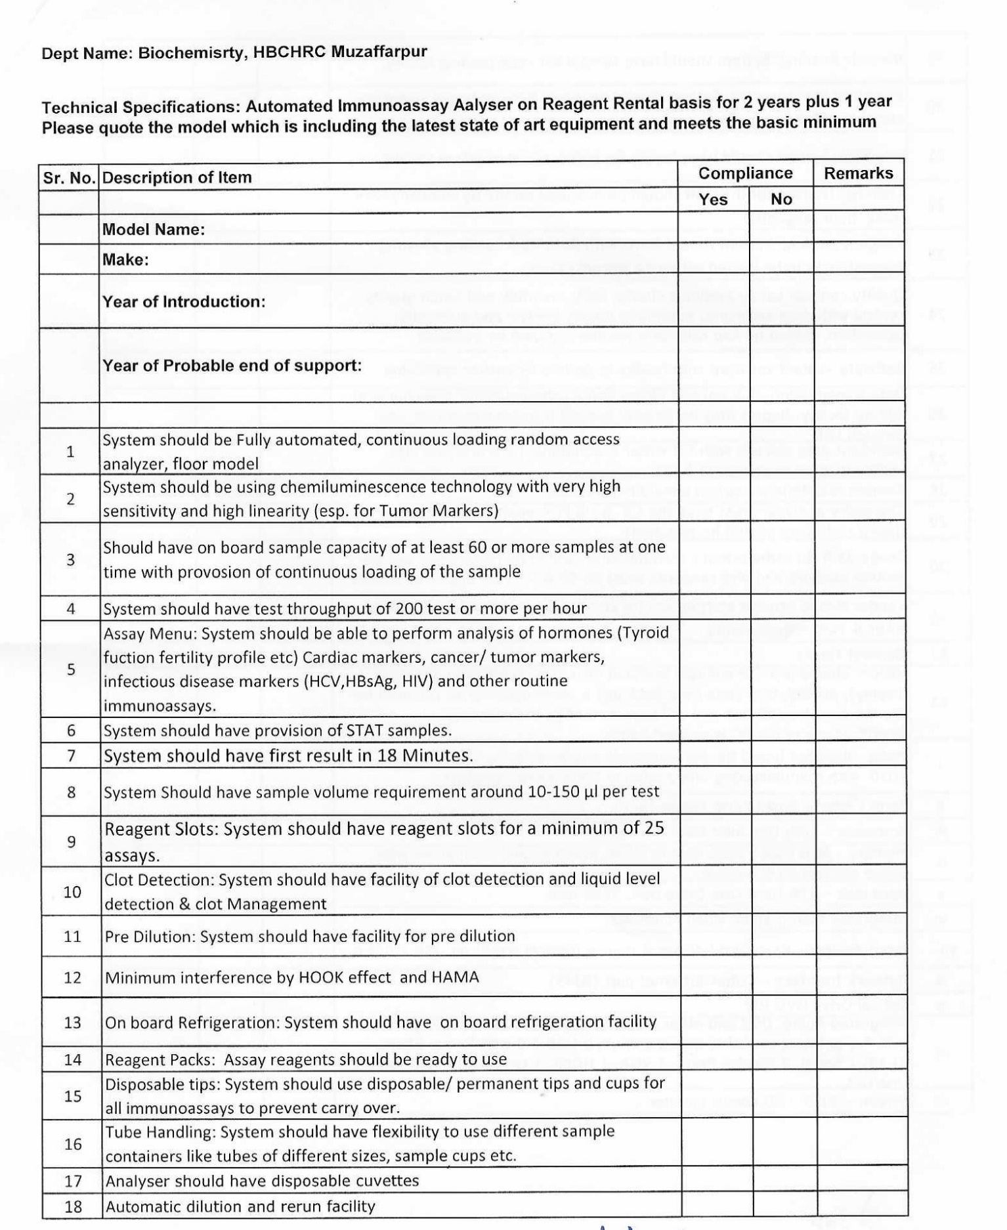

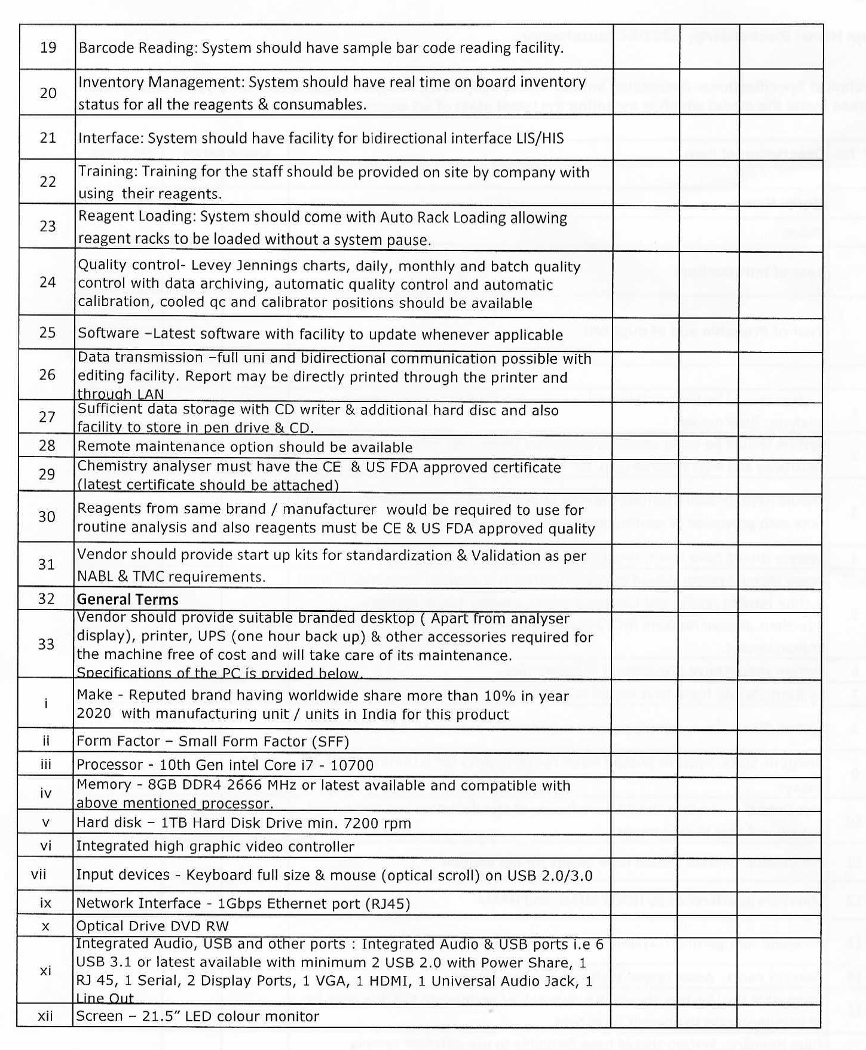

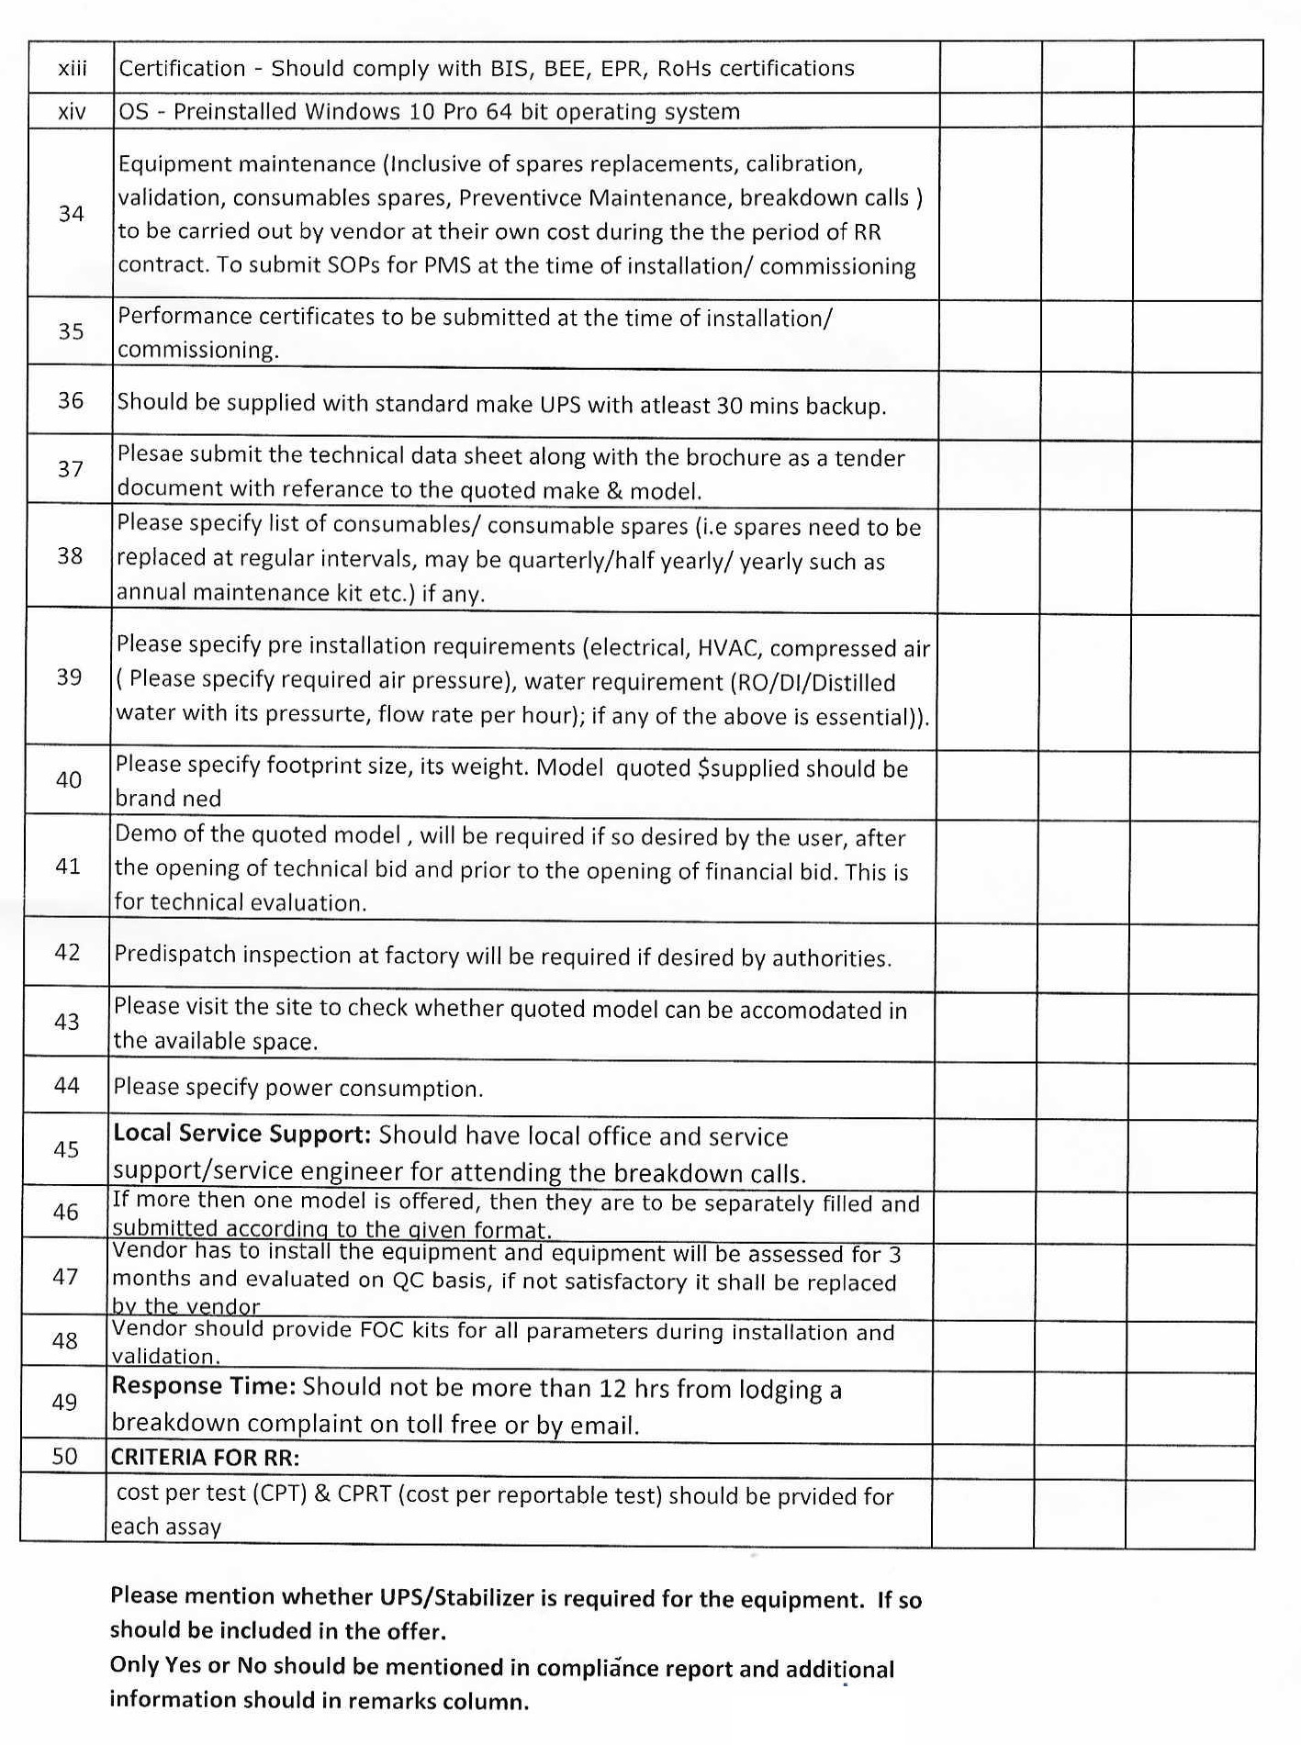

**ANNEXURE ‘B’**

**Bid Security Declaration**

(On Letter Head of the Tenderer)

**Tender No. HBCH/MPMMCC-MZP/OT/02/KE**

We hereby declare and accept that if we withdraw or modify our bid during the period of validity, or if we are awarded the contract and we fail to sign the contract, or fail to submit the performance security before the deadline defined in the NIT, we agree for suspension for a period of TWO years from participating in GeM and in any tender of your Institute which shall be binding on us and we shall not appeal against the same.

Date: Sign of Authorised Signatory

Name:

Designation:

Seal:

**ANNEXURE ‘C’**

TENDER ACCEPTANCE LETTER

(To be given on Company Letter Head)

Date:

To, ______________________

_____________________

Sub: Acceptance of Terms & Conditions of Tender.

Tender Reference No: ________________________________________________________

Name of Tender / Work: - _____________________________________________________

I/We have read the General and Special Terms and Conditions of the contract given above. I /We agree to abide by them.

1. 1. I/ We have downloaded / obtained the tender document(s) for the above mentioned ‘Tender/Work’ from the web site(s) namely: _____________________ as per your advertisement, given in the above-mentioned website(s) and I/We have not tampered /modified the tender documents in any manner. In case the same is found tampered/ modified, I/We understand that my/our offer shall be summarily rejected and I/We are liable to be banned from doing business with HBCH/MPMMCC, Varanasi and/or prosecuted as per laws.

2. I / We hereby certify that I / we have read the entire terms and conditions of the tender documents from Page No. _______ to ______ (including all documents like annexure(s), schedule(s), etc..,), which form part of the contract agreement and I / we shall abide hereby by the terms / conditions / clauses contained therein.

3. The corrigendum(s) issued from time to time by your department/ organization too have also been taken into consideration, while submitting this acceptance letter.

4. I / We hereby unconditionally accept the tender conditions of above-mentioned tender document(s) / corrigendum(s) in its totality / entirety.

5. I / We do hereby declare that our Firm has not been blacklisted/ debarred/ terminated/ banned by any Govt. Department/Public sector undertaking.

6. I / We certify that all information furnished by our Firm is true & correct and, in the event, that the information is found to be incorrect/untrue or found violated, then your department/ organization shall without giving any notice or reason therefore or summarily reject the bid or terminate the contract, without prejudice to any other rights or remedy including the forfeiture of the full said earnest money deposit absolutely.

Yours Faithfully,

Signature of the bidder and seal

Name of authorized person

& Address for correspondence

Tel/Mobile No.

**ANNEXURE ‘D’**

**VENDOR CAPABILITY FORM (APPLICATION)**

Ref: Tender No:                                                                                  Date:

|  |  |
| --- | --- |
| 1 Name of the Item / Work |  |
| 2. Due Date of the submission of the tender. |  |
| 3. Receipt No. for EMD Amount and  Date |  |
| 4. Name / Title of the Bidder |  |
| 5. Full Address (recent) |  |
|  |
|  |
| E-Mail (recent) |
| Tel. No & Mobile No. (recent) |
| Fax (recent) |
| 6.    Name of the person authorized to deal / undertake business for and on behalf of the bidder |  |
|  |
|  |
|  | Tel. No & Mobile No. **(Recent)** |
| Fax **(Recent)** |
| E-Mail (**Recent)** |
| 7. Legal entity of the bidder whether Firm / Society / Company / Other entity |  |
| a.       Registration No. | b.  Authority with whom registered |
| c.       License No. granted by                                                for | |
| 8.   Main business of the bidder whether Manufacturer, Business Distributor, Wholesale Dealer, Retail trader or Service Agent |  |
|  |
|  |
|  |  |
| 9.  Authorized Area of operation in India |  |
|  |
| 10.  Name of the Principal Organization / Company for and on behalf working in India |  |
|  |
|  |
| 11. Origin of the Principal Organization / Company |  |
| 12.  Address of the Principal Organization / Company |  |
|  |
|  |
| Tel. No. & Mobile No. |
| Fax |
| E-Mail |
| 13.  Name & Address of the Bankers along with Bank Account No. and IFSC code of the bidders. |  |
|  |
|  |
| 14.  Authority / Delegation / License No. & Date granted by the principal to the representative bidder |  |
|  |
| 15.  PAN No. |  |
| 16.    Registration No. granted by GST |  |
| 17.    GST/CGST/SGST NO. |  |
| 18. HSN code of the product |  |
| 19.    Import / Export Code No. |  |
| License No. for import |  |
| 20.    No. of manpower employed by the bidder | a. Scientific                      b. Technical |
| c. Administrative             d. Finance |
|  |  |
| 21.    Support facility equipment No. |  |
| 22.    Experience of the bidder in dealing with the tendered item. Tenderer must have similar job done in the line of business / experience with 3 to 5 years will be considered |  |
|  |
|  |
| 23.    Whether supply of any item / service to MPMMCC/HBCH in past; if yes indicate the Purchase Order No. & Date |  |
|  |
|  |
|  |
| 24.    Any other relevant information for submission |  |
|  |
|  |

Certified that the above information is correct & true to the best of my knowledge and belief. Nothing has been concealed and fabricated and in case any information is found incorrect.  I, the under signatory will be personally responsible.

**Name of authorized person for bidder with seal**

**Signature**

## **ANNEXURE ‘E’**

(On Letter Head of the Tenderer)

**MANDATORY CONDITIONS TO BE SATISFIED BY ANY BIDDER FROM A COUNTRY WHICH SHARES A LAND BORDER WITH INDIA**

*(This annexure is to be signed and stamp and submitted by Bidder along with the bid)*

1. The tender shall be governed by the following terms and conditions:
   1. Any bidder from a country which shares a land border with India will be eligible to bid in this tender only if the bidder is registered with the Competent Authority as specified in Order (Public Procurement No.1) F.No.6/18/2019-PPD Dated 23.07.2020 issued by Ministry of Finance, Department of Expenditure, Public Procurement Division and as amended from time to time. Such registration should be valid at the time of submission and acceptance of bids.
   2. "Bidder" (including the term 'tenderer', 'consultant' or 'service provider' in certain contexts) means any person or firm or company, including any member of a consortium or joint venture (that is an association of several persons, or firms or companies), every artificial juridical person not falling in any of the descriptions of bidders stated hereinbefore, including any agency branch or office controlled by such person, participating in a procurement process.
   3. "Bidder from a country which shares a land border with India" for the purpose of this Order means: -
      1. An entity incorporated, established or registered in such a country; or
      2. A subsidiary of an entity incorporated, established or registered in such a country; or
      3. An entity substantially controlled through entities incorporated, established or registered in such a country; or
      4. An entity whose beneficial owner is situated in such a country; or
      5. An Indian (or other) agent of such an entity; or
      6. A natural person who is a citizen of such a country; or
      7. A consortium or joint venture where any member of the consortium or joint venture falls under any of the above
   4. The beneficial owner for the purpose of (iii) above will be as under:
2. In case of a company or Limited Liability Partnership, the beneficial owner is the natural person(s), who, whether acting alone or together, or through one or more juridical person, has a controlling ownership interest or who exercises control through other means.

Explanation-

1. "Controlling ownership interest" means ownership of or entitlement to more than twenty-five percent of shares or capital or profits of the company;
2. "Control" shall include the right to appoint majority of the directors or to control the management or policy decisions including by virtue of their shareholding or management rights or shareholders agreements or voting agreements;
3. In case of a partnership firm, the beneficial owner is the natural person(s) who, whether acting alone or together, or through one or more juridical person, has ownership of entitlement to more than fifteen percent of capital or profits of the partnership;
4. In case of an unincorporated association or body of individuals, the beneficial owner is the natural person(s), who, whether acting alone or together, or through one or more juridical person, has ownership or entitlement to more than fifteen percent of the property or capital or profits of such association or body of individuals;
5. Where no natural person is identified under (1) or (2) or (3) above, the beneficial owner is the relevant natural person who holds the position of senior managing official;
6. In case of a trust, the identification of beneficial owner(s) shall include identification of the author of the trust, the trustee, the beneficiaries with fifteen percent or more interest in the trust and any other natural person exercising ultimate effective control over the trust through a chain of control or ownership.
   1. An Agent is a person employed to do any act for another, or to represent another in dealings with third person.
   2. The successful bidder shall not be allowed to sub-contract works to any contractor from a country which shares a land border with India unless such contractor is registered with the Competent Authority.
   3. Certificate regarding compliance: **A certificate shall be provided by bidders in the tender documents regarding their compliance with these clauses**. If such certificate given by a bidder whose bid is accepted is found to be false, this would be a ground for immediate termination and further legal action in accordance with law.
   4. Validity of registration: In respect of tenders, registration should be valid at the time of submission of bids and at the time of acceptance of bids. If the bidder was validly registered at the time of acceptance / placement of order, registration shall not be a relevant consideration during contract execution.
7. Not with standing above, the terms and conditions mentioned above will not apply to bidders from those countries (even if sharing a land border with India) to which the Government of India has extended lines of credit or in which the Government of India is engaged in developing projects.

"I have read the clause regarding restrictions on procurement from a bidder of a country which shares a land border with India and on sub-contracting to contractors from such countries; I certify that this bidder is not from such a country or, if from such a country, has been registered with the Competent Authority and will not sub-contract any work to a contractor from such countries unless such contractor is registered with the Competent Authority. I hereby certify that this bidder fulfills all requirements in this regard and is eligible to be considered. [Where applicable, evidence of valid registration by the Competent Authority shall be attached.]"

Dated: Authorized Signatory:

Name:-

Designation:-

Seal:-

**Annexure F**

To be printed & executed on Letter head of the principal supplier/manufacturer of the equipment of foreign origin

**LETTER OF AUTHORIZATION**

I, Mr. _____________________________ Chairman / Managing Director / President / Vice-President / General Manager hereby certify and declare that   
M/s. ______________________________________ having its registered office at  ____________________________________________________________ is an organization dealing with the manufacturing and assembling of the equipment _________________________________ which is meant for scientific use for research/diagnostic/treatment and having business operations in India.

It is also certified that our representation and operations in India is done & executed by   
M/s. _________________________________________ which is an organization constituted under the provisions of _____________________________ and having their registered office at ________________________________________ who has been fully authorized by us to act as our representative in whole or part of India to deal, undertake, participate in the business proceedings, quote rate for supply, installation, testing and commissioning, after sales services of our products / equipment and their spare parts together with consumables and procure purchase orders to pass to us on such rates and conditions as may be negotiated by them for and on behalf of us.

The Indian agent M/s. ___________________________________ has also been authorized to provide after sales services, supply spare parts and consumables on the authorized rates as indicated in the price list of the company. They have also been authorized to negotiate the rate for allowing special discount to the hospital.

**Signature**

**Date:                                                            Name of authorized person for bidder with seal**

**Annexure G**

To be printed & executed on Letter head of the supplier company / Indian agent

**UNDERTAKING**

To,

The Director,

1.         I, the under signatory hereby undertake to supply, install and erect, testing & commission and maintenance of the equipment namely ____________________________________ for and on behalf of bidder on agreed terms and conditions as have been stipulated and mentioned in the Purchase order on acceptance of my offer for the above equipment / item.

1. I, the undersigned also hereby undertake to assure and promise to provide the spare parts within reasonable time for operation of the aforesaid equipment without any charge during the warranty period of NIL **years** and thereafter I will make available all the spare parts and consumables on the agreed price from the date of completion of the warranty period at the negotiated rate allowing discount on the price list of the company, authenticated copy of which will be submitted for your record.

3.         Further also, I undertake to assure and promise to provide technical operational training to the scientific and technical staff members of the user Institute without any charge after commissioning of the equipment and condition thereof.  In case training experts are not available in India the necessary operational training not exceeding to one week shall be arranged by the manufacturing company of the equipment in the manufacturing / assembling unit of the equipment in the foreign country of origin.

**Signature**

**Date:                                                            Name of authorized person for bidder with seal**

**Annexure-H**

To be printed & executed on Letter head of the supplier company / Indian agent

**Schedule of disclosure of existing customers to whom supply of similar equipment / service made available in India**

**CERTIFICATE**

This is to certify that M/s. __________________________________________ having manufacturing factory / unit at __________________________________________________ and having registered office at ________________________________________________ is a company registered and incorporated company under the Law of the land of ____________________, is our the principal company manufacturing the equipment namely _____________________________.  The said equipment has been supplied, installed and successfully commissioned with the users as are listed with their addresses in annexure hereto.

This is also to certify that we have not supplied above named equipment to any of the users in India at the cost less than the price quoted by us to Director, TMH-TMC, within the period of last six months.

**Signature**

**Date:                                                            Name of authorized person for bidder with seal**

# Annexure – I

# TECHNICAL BID

**TENDER No. HBCH/MPMMCC-MZP/OT/02/KE**

If the tenderer is not capable of quoting particular item tenderer should clearly mention in the Technical bid in the compliance report. For the cases where in the compliance report if the tenderer not mentioned anything then management is free to presume that it is inclusive of the cost quoted by the tenderer.

|  |  |  |  |  |
| --- | --- | --- | --- | --- |
| **Sl. No.** | **Item Description** | **Qty.**  **(Approx.)** | **Item Offered /Quoted**  **(Yes/No)** | **Dully filled Technical Compliance sheet for technical specification as per Annexure A1 & A2 submitted (Yes/No)** |
| **1** | **Immunoassay Analyser Automated on Reagent Rental Contract**  **As per technical specifications** | **01 No.** |  |  |
| **1.1** | **Reagents for Immunoassay Analyzer Automated** |  |  |  |

*Note: Please quote only YES OR NO for the offered item & do not quote the prices in the technical Bid and in case the price is quoted in the Technical Bid the said offer will be summarily rejected.*

*Submission of technical compliance sheet for offered item/s as per Annexure A1* ***for Immunoassay Analyser Automated on Reagent Rental Contract is mandatory for consideration*** *& Technical evaluation of the offer.*

**Please furnish the following details in the given proforma.**

|  |  |  |
| --- | --- | --- |
| **Sl. No.** | **Documents/Details** | **Compliance**  **(Details & Yes/No)** |
| **1** | Bid Security Declaration (as per format at Annexure B) | Copy Enclosed …………………………………… Yes/No |
| **2.** | Bidder Category i.e. Manufacture /Distributor /Dealer / Trader/Supplier **relevant document should be Submitted.** | ………………………………………………………….  Copy Enclosed …………………………………… Yes/No |
| **3** | Copy of PAN, duly signed & stamped. | ) PAN No…………………...............................  ii) Copy of Certificate Enclosed …………..Yes/No |
| **4** | Copy of GST Registration Certificate, duly signed & stamped, clearly mentioning the GSTIN number. | i) Registration No…………………...............................  ii) Copy of Certificate Enclosed …………..Yes/No |
| **5** | Evidence for supply of similar nature of items in government hospital / reputed private hospital/ reputed organizations for similar nature of items in the last two years. | Enclosed ……………………………………………. Yes/No |
| **6** | Tender Acceptance Letter in the format enclosed at Annexure-C | Enclosed ……………………………………………. Yes/No |

Certified that the above information is correct & true to the best of my knowledge and belief.  In case any information is legal suppressed, and /or found false and incorrect, the under signatory will be personally responsible for the consequences, and that the tender is liable to be rejected summarily without assigning any reason.

**Signature of the Bidder and Seal**

**Annexure -II**

**Part II (COMMERCIAL BID)**

**TENDER No. HBCH/MPMMCC-MZP/OT/02/KE**

**Name of the Vendor :**

**Name of Equipment : Immunoassay Analyser Automated FOR BIOCHEMISTRY on Reagent Rental Contract for 3 years plus 1 year extendable, Quantity 1 no.**

**Model :**

**Make :**

*The details of the price the equipment should be quoted in Part II of the tender in a **separate sealed envelope**

|  |  |  |  |  |  |
| --- | --- | --- | --- | --- | --- |
| **Sl. No.** | **Items Description / specification** | **Required**  **Qty.** | **Unit Rate (Basic Price)**  **(INR)** | **GST %**  **& GST Value**  **(INR)** | **TOTAL Unit Price**  **(INR)** |
| **1** | **Immunoassay Analyser Automated on Reagent Rental Contract**  **As per technical specifications at Annexure A1** | **01 No.** | **XX** | **XX** | **XXX** |

**Following points shall be considered for arriving at the lowest quoted bidder amongst the technically acceptable offers.:**

**FOR REAGENT RENTAL**

**L1 Grading will be done based on the cost per test CPRT**

List of consumables and reagents required:

|  |  |  |  |  |  |  |  |  |
| --- | --- | --- | --- | --- | --- | --- | --- | --- |
| **Sr.No.** | **Name of Reagents/ consumables, etc.** | **Pack Size** | **Unit Rate (Rs.)** | **Taxes**  **(GST)** | **Test per Pack** | **Cost per test** | **CPRT** | **MRP (Rs.) without tax** |
|  |  |  |  |  |  |  |  |  |
|  |  |  |  |  |  |  |  |  |
|  |  |  |  |  |  |  |  |  |
|  |  |  |  |  |  |  |  |  |
|  |  |  |  |  |  |  |  |  |

Note:

1. The quoted rate should be FOR: Destination i.e. for supply of items up to Stores, HBCH&RC, Muzaffarpur
2. This is a fixed price tender. Any request for rate revision till currency of Contract shall not be considered.
3. The currency of all quoted rates shall be in Indian Rupees. All payment shall be made in Indian Rupees.

**Signature of the Bidder and Seal**